**Diagonal Difference**

**1- Non-recursive:**

**1.1- Implementation:**

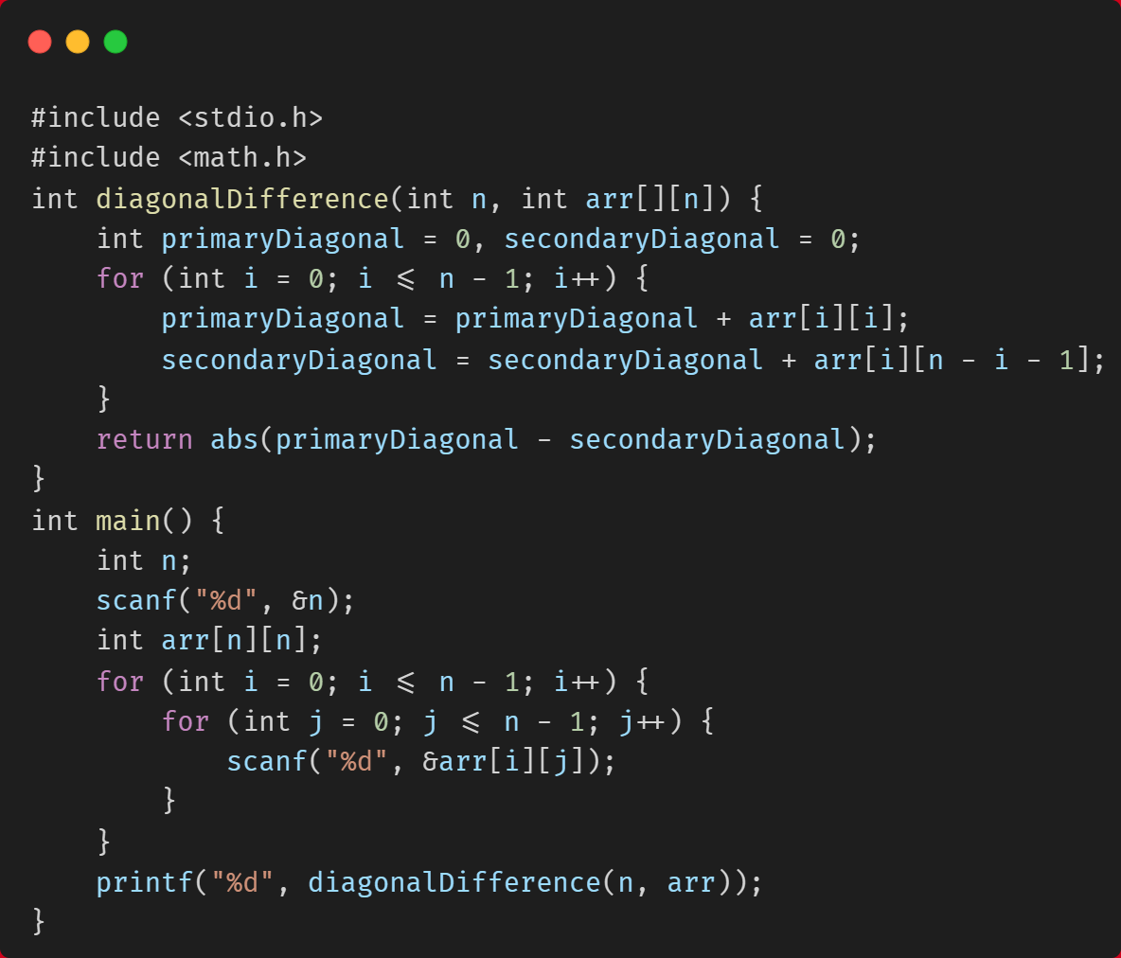

**1.2- Documentation:**

**ALGORITHM DiagonalDifference(n, arr) {**

**primaryDiagonal <- 0**

**secondaryDiagonal <- 0**

**for i <- 0 to n – 1 do**

**primaryDiagonal <- primaryDiagonal + arr[i][i]**

**secondaryDiagonal <- secondaryDiagonal + arr[i][n - i - 1]**

**return abs(primaryDiagonal - secondaryDiagonal)**

**}**

**So, Time Complexity is Θ(n)**

**2- Recursive:**

**2.1- Implementation:**

**2.2- Documentation:**

**ALGORITHM DiagonalDifference(n, arr, i) {**

**If (i = n)**

**return 0**

**return arr[i][i] – arr[n – i – 1] + DiagonalDifference(n, arr, i + 1)**

**}**

**So, Time Complexity is Θ(n)**